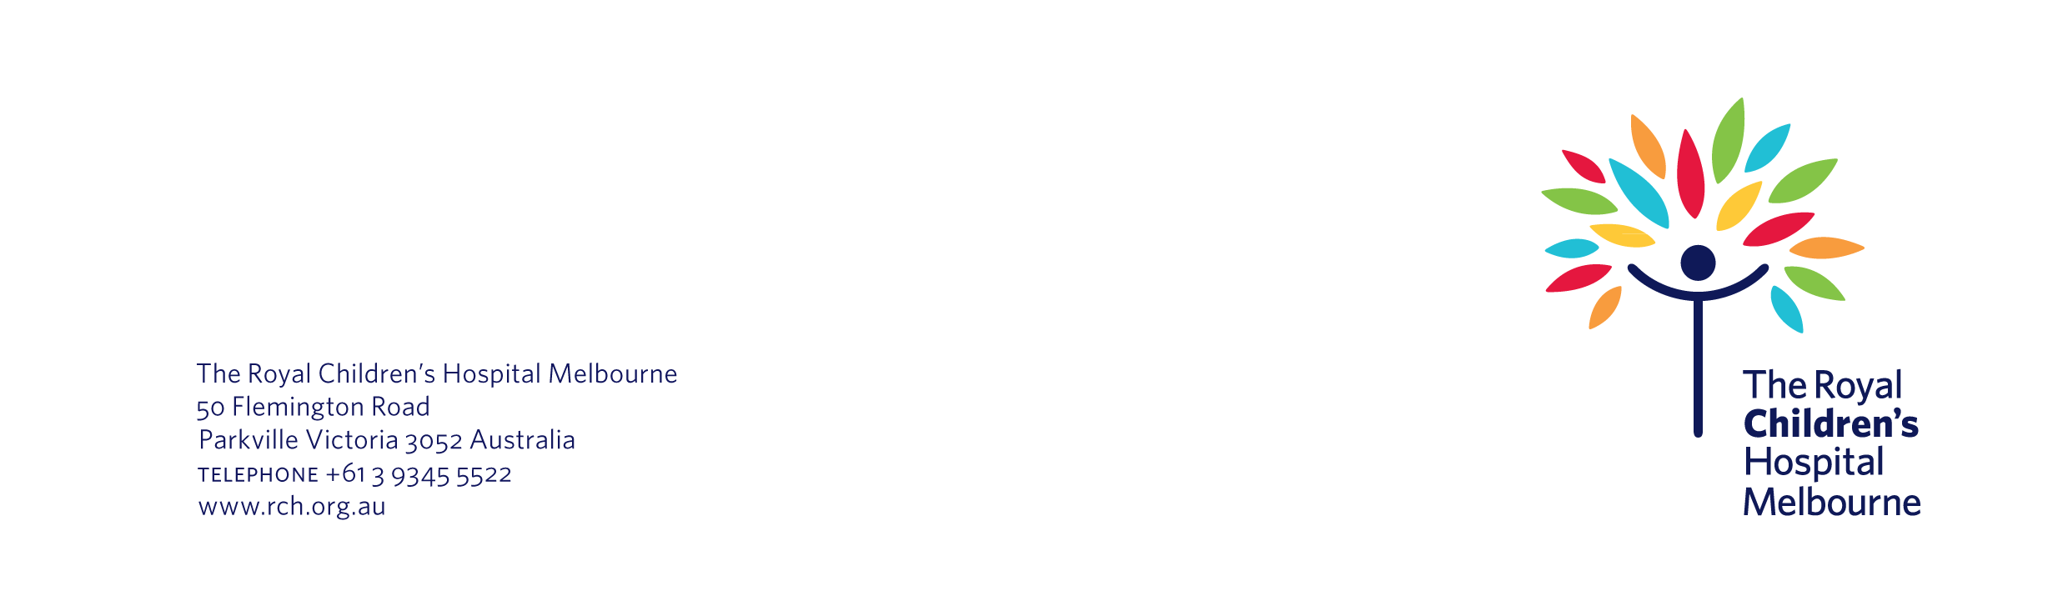
Number / Street Name
Suburb
State / Postcode

Date

Re: We would like to use your child’s information for a <registry/research project>

Dear <insert name>,

We would like to use <insert child’s name> information for the <insert name of registry/ insert name of research project>. Our files indicate that your child’s medical records may provide useful data for this <registry/research project>.

<The registry is a way of collecting information about people with <insert name of condition>. The aim of the registry is to <insert details>. The registry is run by <insert details>.

Or

<The aim of research project is to <insert details>. It is run by <insert details>.

We will use your child’s information for this <registry/research project> unless you tell us not to.

The rest of this letter gives you more information about the <registry/research project>. It also tells you how you can opt out of the <registry/research project> if you want to.

What information will we give the <registry/research project>?

We would like to give the <registry/research project> your child’s:

- <list the types of information that you are going to give the registry/research project. Delete / expand on the below types of information as relevant
- health information, such as information about your child’s condition and medical history
- personal information, such as your child’s name, date of birth, sex
- height and weight measurements>.

<The reason why the registry collects identifying information about people is to make sure that their records are not duplicated if they move to another hospital. It also allows for data audits and linkage with other information such as hospital laboratory records.>

We will get your child’s information from:

- <list the places where you will get this information. Delete/expand on the below examples as relevant
- your child’s medical records
- your child’s GP
- other research sites or databases that are linked with this <registry/research project>, such as XXX>.

Why does the <registry/research project> need this information?

The aim of the <registry/research project> is to find out more information about <insert name of condition>. We hope that it will help answer questions such as:

- <list the aims of the registry/research project. Delete / expand on the below questions as relevant
- how many people in Australia are affected by <name of condition>?
- what treatments work best for people with <name of condition>?
- what are the long-term outcomes for people with <name of condition>?
- how can health services provide better care for people with <name of condition>?>

The <registry/research project> will use this information to <insert details>.

Who will have access to your child’s information?

The following people and organisations – also called ‘third parties’ – will have access to the <registry/research project>:

- <list the third parties that will have access to the registry/research project. Delete / expand on the below list as relevant
- The Royal Children’s Hospital
- Murdoch Children’s Research Institute
- researchers from around the world.>

<These third parties will not be able to find out any specific information about your child, such as their name or date or birth. They will only have access to <insert details, e.g. whole-of-group data about people with <insert name of condition>>.

How will the <registry/research project> store your child’s information?

Your child’s information will be stored on <insert details, for example a password protected cloud based server> at <insert name of organisation> in <location, for example, Australia / United States>.

<Because the information will be stored in Australia, it will be protected by Australian privacy laws.>

Or

<Because the information will not be stored in Australia, it will not be protected by Australian privacy laws.>

What are the risks?

The main risk to your child is a potential breach of privacy. However, as we have explained, we will protect your child’s privacy by <insert details>.

Ethics

The <registry/research project> has been approved by <The Royal Children’s Hospital Human Research Ethics Committee / insert name of other ethics committees if relevant>.

What happens next?

a. If you agree to share your child’s information

If you are happy for us to share your child’s information you do not have to do anything. We will simply give your child’s information to the <registry/research project>.

The <registry/research project> will store your child’s information for <an unlimited period/X years>. <If your child turns 18 while the registry is still collecting information, the registry will send them a letter. This letter will tell them about the registry and let them know they can stop being part of it if they want to.>

<You can also withdraw your child’s information from the <registry/research project> at any time.

Or

You will not be able to remove your child’s information from <registry/research project>.

b. If you do not agree to share your child’s information

If you do not want us to share your child’s information with the <registry/research project>, please contact us within four weeks of the date of this letter. That is, the <insert date>.

You can get in touch with us several ways:

Post Fill out the opt out form attached to this letter and return it to us in the enclosed self-addressed, reply-paid envelope.

Email Send <insert name> an email at <insert email address>.

Phone Call <insert name> on <insert number>.

Do you have any questions?
Please get in touch if you have any questions about this letter. You can contact <insert name> on <insert phone number>. You can also email them on <insert email address>.

Thank you very much for your time.

Kind regards

Name
Department
The Royal Children’s Hospital

Opt Out Form

HREC project number: | <insert HREC number here if relevant, otherwise delete this line >
Name of <registry/research project>: | <insert short plain language title>

I do not consent for you to pass on my child’s information to the <insert name of <registry/research project>.

Child’s Name

Parent/Guardian Name |  | Parent/Guardian Signature |  | Date

You can contact the Director of Research Operations at The Royal Children’s Hospital if you:
- have any concerns or complaints about the project
- are worried about your rights as a research participant
- would like to speak to someone independent of the project.
You can phone the Director on (03) 9345 5044 or email them at rch.ethics@rch.org.au.

